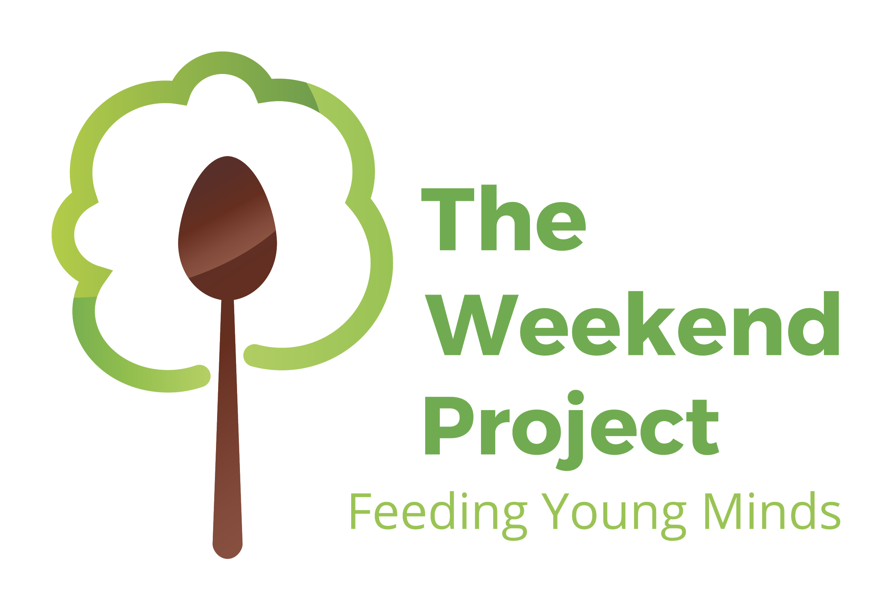
The Weekend Project: Feeding Young Minds was initiated to provide students with meals for the weekend. Our weekend food packs are quick, easy, and kid-friendly! Each pack contains food for an individual student. We know that students with enough to eat are ready to learn. By feeding the young minds in our community, we hope to help our future leaders concentrate on school and not empty stomachs.

Students enrolled in The Weekend Project will receive:
- 2 breakfast items (such as oatmeal packet or cereal bar)
- 2 dinner items (such as a can of soup or a cup of macaroni)
- 2 snacks (such as a mini bag of pretzels or crackers)
- 2 fruits (such as fruit cups)

Could you benefit from this?
Are you living on a limited income?
Has your family income changed because of a job change/loss?
Are you working on the weekend when your child needs to eat?

There are NO cost or income requirements (the program is funded by community support). If you are interested in this program, please fill out the bottom portion and return to Sauk Centre Elementary School Office at the Open House or by mail.

Sauk Centre Elementary School
Attn. Weekend Project
903 State Road, Sauk Centre MN 56378

For more information you can go to theweekendproject.org or email us at theweekendproject16@gmail.com
_________________________________________________________________________________________

_____Yes! Please sign my child up to receive a food pack each weekend

My child has the following food allergy/diet restriction: ___________________________________

Please circle: We DO or DO NOT have a microwave in our home.

Child’s name______________________________ Grade_____ Teacher_______________

Parent Signature____________________________________________________________

